Program I – Pocket Calculator
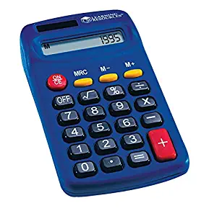
In this lab, you will create a GUI implementation of a simple pocket calculator. The minimum requirements are as follows:
- Number Buttons
- Equal Button
- Add Button
- Subtract Button
- Multiply Button
- Divide Button
- Clear Button

Of course, there are more possibilities than this. If, for instance, you were to add a memory function, square root button, or percent calculations I would give you extra credit. If you made something that modeled a real world scientific calculator, you will get even more extra credit!
As a general set of requirements, your submission must have the following:
- Source Code
- Makefile that will compile the program when I type ‘make’ in your directory
I would recommend designing this assignment thoroughly before trying to create it. The reason for this is that even a simple calculator is a bit more complex than it looks. What I did to generate this was as follows:
- I created a class, Calculator, which models the behavior of the calculator. It has functions for each button press, and a function for retrieving the calculator’s display.
- I made a test program that ran through keypresses and printed the screen to verify that the class works in text mode.
- I then designed a GUI using fluid, and then I wrote callbacks which use my business logic class to do the math.
- I wrote a separate main.cpp file which creates the main window and enters the event loop.
This three tiered approach: business, gui, and program, is the standard way to write this sort of application.
Good luck, and enjoy!

